ENGLISH (EN)

Guidelines for Rotary Foundation-Funded Project Signage and Use of Name “Rotary” or other Rotary Marks

Recipients of Rotary Foundation grant funds should provide appropriate project signage as outlined below (and in section 40.010.2 of The Rotary Foundation Code of Policies). Please see page three of this document for a sample project sign.

40.010.2. Recognition Plaque for TRF Funded Projects
The Trustees have approved a plaque design as a recommended model for signage to be placed on or in conjunction with Rotary projects that are funded by The Rotary Foundation. Rotarians should include signage on or in conjunction with their projects so as to identify the role of the grant sponsors and The Rotary Foundation in the grant projects.

The general secretary is authorized to revise the recommended design as required. The general secretary is requested to include the design in The Rotary Foundation grants publications and correspondence. (September 2011 Trustees Mtg., Dec. 7)
Source: April 2011 Trustees Mtg., Dec. 125

Grant recipients must also comply with the policies regarding the proper use of the name “Rotary” or other Rotary Marks as outlined below (and in sections 34.040.6 and 34.040.11 of the Rotary Code of Policies).

34.040.6. Use of Name “Rotary,” or other Rotary Marks by Rotary Entities
When used by itself, the word “Rotary” or the Rotary Emblem normally refers to the entire organization, Rotary International. It also means the ideals and principles of the organization. All club, district, multidistrict and other Rotary Entity activities, projects or organizations must include identifiers of the club, district, multidistrict group or other Rotary Entity when using the name “Rotary,” or other Rotary Marks. In limited instances and in RI’s sole discretion, a geographic identifier may be used, provided it accurately represents the interests of each club in that area and appropriate approvals are sought from the district governors and/or the club presidents. Such identifier must immediately follow or precede “Rotary.” Such identifier must be in close proximity to and in equal prominence with the Rotary Emblem or other of the Rotary Marks.

The Rotary Marks must always be reproduced in their entirety. No abbreviations, prefixes or suffixes such as “Rota” are permitted, except for use in “Interota” for the periodic Interota meetings. No alterations, obstructions or modifications of the Rotary Marks are permitted. To accommodate digital media and enhance an accurate reproduction of the Rotary emblem, a specially modified emblem may be used for replications smaller than 0.5 inches (1.27 cm), such modified emblem to be used only together with “Rotary” as part of the “digital and small space signature lock-up” or with “Interact” or “Rotaract” as part of the digital and small space simplified signatures for the Programs logos. To accommodate the embroidery medium, the modified Rotary emblem may be used on licensed and other RI authorized articles of clothing in replications greater than 0.5 inches (1.27 cm) but only in sizes too small to accommodate accurate reproduction of the Rotary emblem, provided the modified Rotary emblem is always used together with “Rotary,” “Interact,” or “Rotaract” in the simplified signature format.

For correct color reproductions of the Rotary emblem and other of the Rotary Marks, current guidelines are found in the Brand Center at https://brandcenter.rotary.org and in “Voice and Visual Identity Guidelines,” which give further specifications for reproducing the Rotary emblem and guidelines for maintaining a standardized, coordinated identity for all Rotary materials (547A).

Rotary Entity activities, projects or organizations that are to include the name “Rotary,” or other Rotary Marks without a further qualifier, must first seek an exception to policy from the Board. Rotarians coordinating existing activities, projects and organizations should review and make necessary changes consistent with this policy. (October 2015 Mtg., Bd. Dec. 37)

Source: February 1996 Mtg., Bd. Dec. 198; May 2000 Mtg., Bd. Dec. 399; Amended by May 2003 Mtg., Bd. Dec. 368; May 2011 Mtg., Bd. Dec. 202; June 2013 Mtg., Bd. Dec. 242; January 2015 Mtg., Bd. Dec. 117; May 2015 Mtg., Bd. Dec. 166; May 2015 Mtg., Bd. Dec. 195; July 2015 Mtg., Bd. Dec. 16; October 2015 Mtg., Bd. Dec. 37

34.040.11. Use of Name “Rotary” in Connection with Club Activities
Use of the word “Rotary” in connection with or in the name of an activity of a club or group of clubs must relate the activity directly to such club or group of clubs and neither directly or indirectly to Rotary International. Use of the word “Rotary” is not authorized in connection with or in the name of an activity that is not under full control of a Rotary club or group of Rotary clubs or in connection with or in the name of any organization, the membership of which includes non-Rotarian individuals or organizations. (See Rotary Code of Policies section 34.040.6.) (July 2015 Mtg., Bd. Dec. 16)
Source: March 1961 Mtg., Bd. Dec. 206; May 2011 Mtg., Bd. Dec. 202. Affirmed by June 2001 Mtg., Bd. Dec. 383

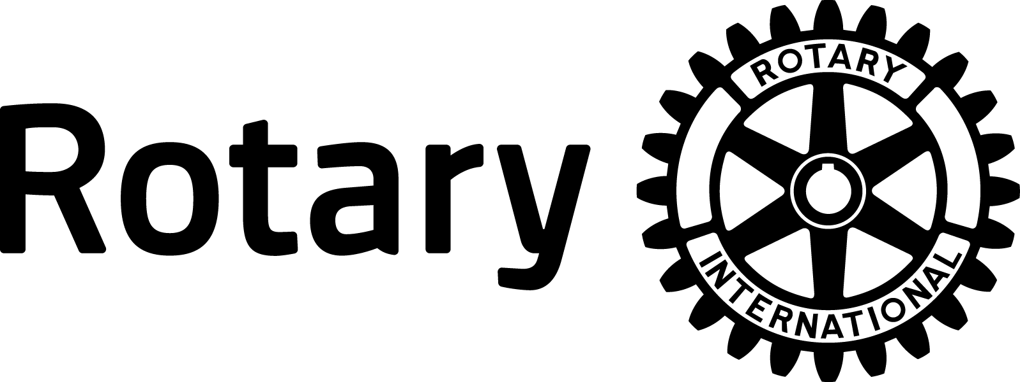
Project Type/Area of Focus
(e.g. basic education and literacy, water and sanitation, etc.)
Name(s) of Rotary Club and/or District
Project Country

Name(s) of Rotary Club and/or District
Outside Project Country

List of Additional Clubs and/or Districts Involved

This project was made possible in part by a grant from
THE ROTARY FOUNDATION OF ROTARY INTERNATIONAL

